Course Title : Big Data Analytics
Course Code : Z1AMC 702
Name: Saumya Patel Registration No: 2511042210022

Experiment 1: Hadoop Single Node Installation

- Objective
To install and configure Hadoop in a single-node environment and verify the successful execution of Hadoop Distributed File System (HDFS) and YARN services.
- Procedure
- Install Java Development Kit (JDK).
- Download and extract the Hadoop package.
- Configure environment variables in .bashrc.
- Configure Hadoop files:
  - core-site.xml
  - hdfs-site.xml
  - mapred-site.xml
  - yarn-site.xml
- Format the NameNode using:
hdfs namenode -format

- Start HDFS services using:
start-dfs.sh

- Start YARN services using:
start-yarn.sh

- Verify running services using:
jps

- Access Hadoop web interfaces:
  - NameNode: http://localhost:9870
  - ResourceManager: http://localhost:8088
- Source Code
export JAVA_HOME=/usr/lib/jvm/java-11-openjdk-amd64
export HADOOP_HOME=/usr/local/hadoop
export PATH=$PATH:$HADOOP_HOME/bin:$HADOOP_HOME/sbin
hdfs namenode -format
start-dfs.sh
start-yarn.sh
jps
- Screen Shot
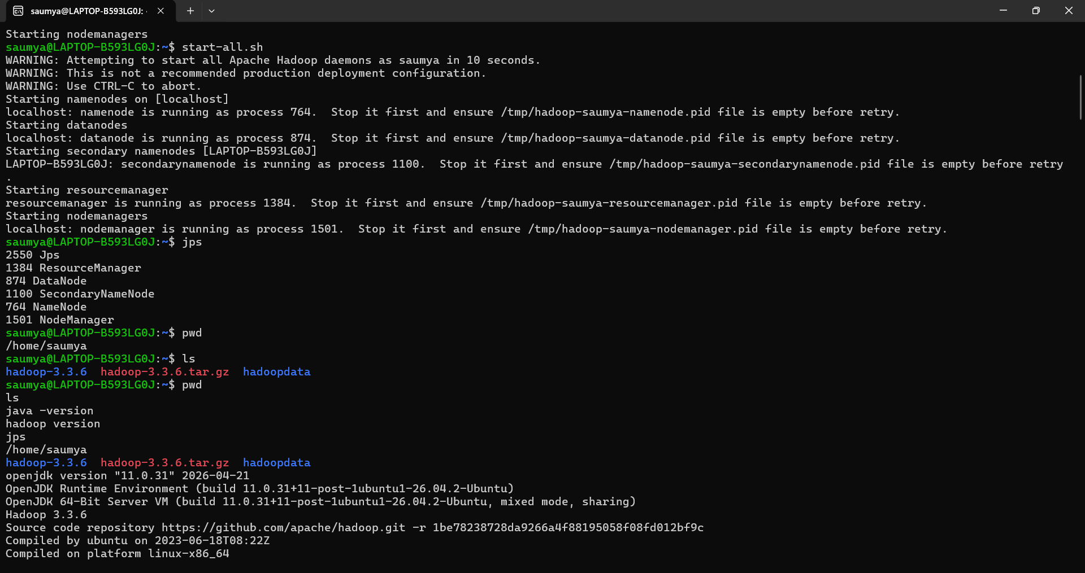
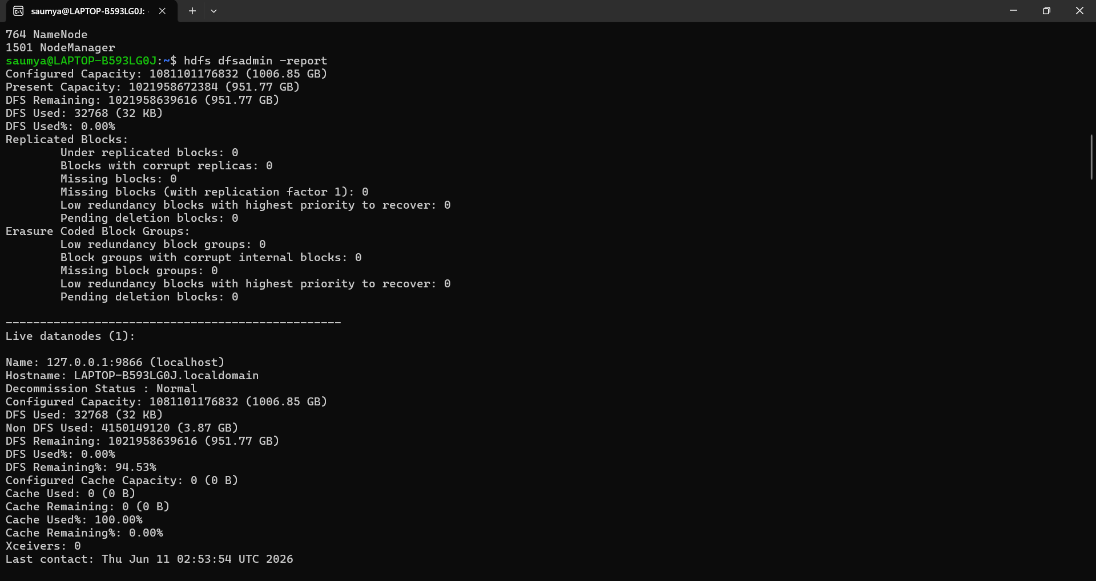

- Conclusion
Hadoop was successfully installed and configured in a single-node environment. HDFS and YARN services were started and verified using JPS and web interfaces.

